World's biggest earthquakes since 1900
February 27, 2010 -- Updated 1906 GMT (0306 HKT)

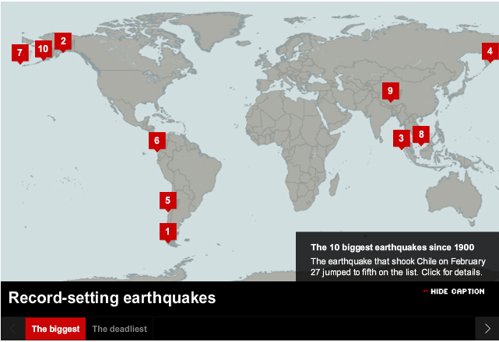

- Magnitude 9.5, Southern Chile - May 22, 1960
- Magnitude 9.2, Prince William Sound - March 27, 1964
- Magnitude 9.1, Coast of Sumatra - December 26, 2004
- Magnitude 9.0, Kamchatka, Asia - November 4, 1952
- Magnitude 8.8, Chile - February 27, 2010
- Magnitude 8.8, Coast of Ecuador - January 31, 1906
- Magnitude 8.7, Rat Islands - February 4, 1965
- Magnitude 8.6, Northern Sumatra - March 28, 2005
- Magnitude 8.6, Assam/Tibet - August 15, 1950
- Magnitude 8.6, Andreanof Islands - March 9, 1957
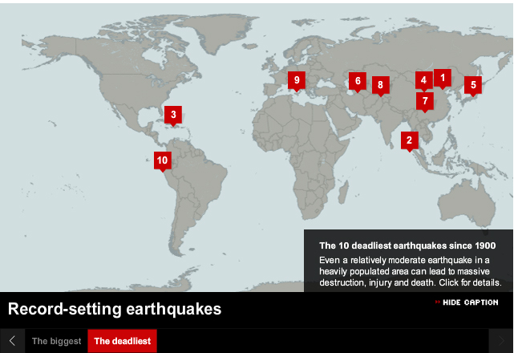

- Magnitude 7.5, Tangshan, China (July 27, 1976)
- Magnitude 9.1, Coast of Sumatra (December 26, 2004)
- Magnitude 7.0, Haiti, (January 12, 2010)
- Magnitude 7.8, Haiyuan, China (December 16, 1920)
- Magnitude 7.9, Kwanto, Japan (September 1, 1923)
- Magnitude 7.3, Turkmenistan (October 5, 1948)
- Magnitude 7.9, Eastern Sichuan, China (May 12, 2008)
- Magnitude 7.6, Northern Pakistan (October 8, 2005)
- Magnitude 7.2, Messina, Italy (December 12, 1908)
- Magnitude 7.9, Chimbote, Peru (May 31, 1970)

(CNN) -- The 8.8-magnitude earthquake that hit Chile on February 27 was similar in intensity to the fifth most powerful quake recorded since 1900.
That quake struck off the coast of Ecuador in 1906. It is not known how many people were killed.
The biggest quake recorded since 1900 hit the coast of southern Chile on May 22, 1960. The 9.5-magnitude quake killed more than 1,600 and left about 2 million people homeless.
http://edition.cnn.com/2010/WORLD/americas/02/27/top10.earthquakes.chile/index.html?hpt=T1

